**Name: _Pan_Chen_**_______

**Lab 2**

**Problem 1:**

**Business rules:**

A customer can make as many calls as he/she wants.

A call can only be handled by one customer service representative.

A customer service representative could handle as many calls as assigned to him or her.

A customer service representative earns salary once each month on the first day.



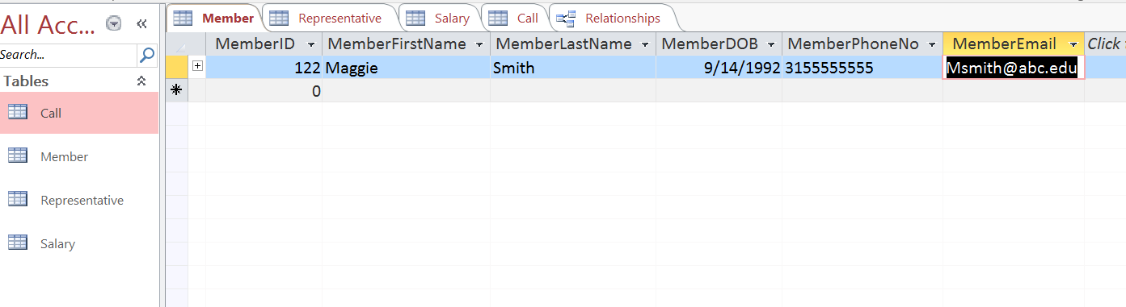

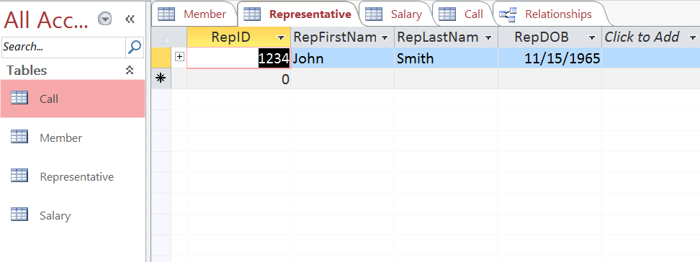



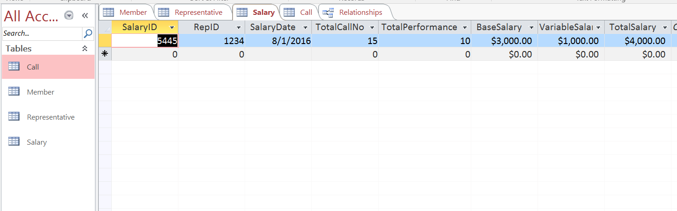

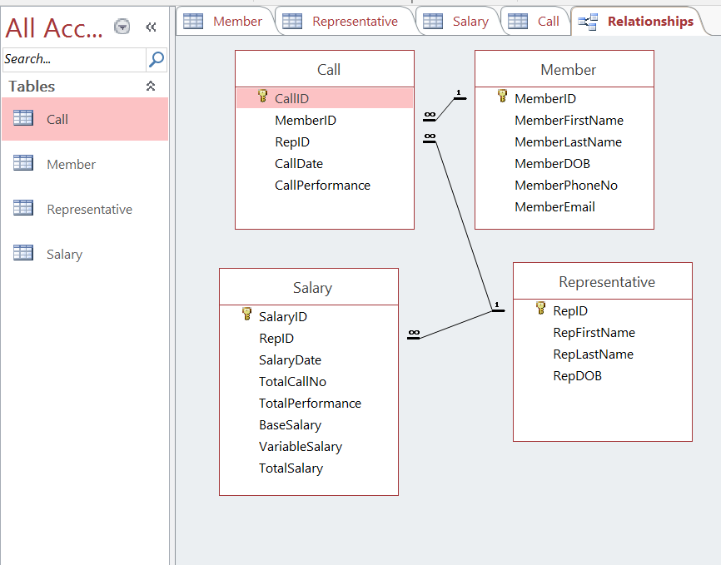

**Problem 2:**

**Business Rules:**

A student could earn many grades from different courses, one from each completed course.

A professor could give grades to different students in different courses he/she teach, one for each student in each completed course.

A course could only be taught by one professor.

A course could have many grades for different students, each student enrolled in a course will earn a grade after completing the course.





